Good attendance and punctuality are essential if you are to succeed at the Highlees Primary School, in fact research shows that there is a direct link between good attendance and academic progress and achievement.
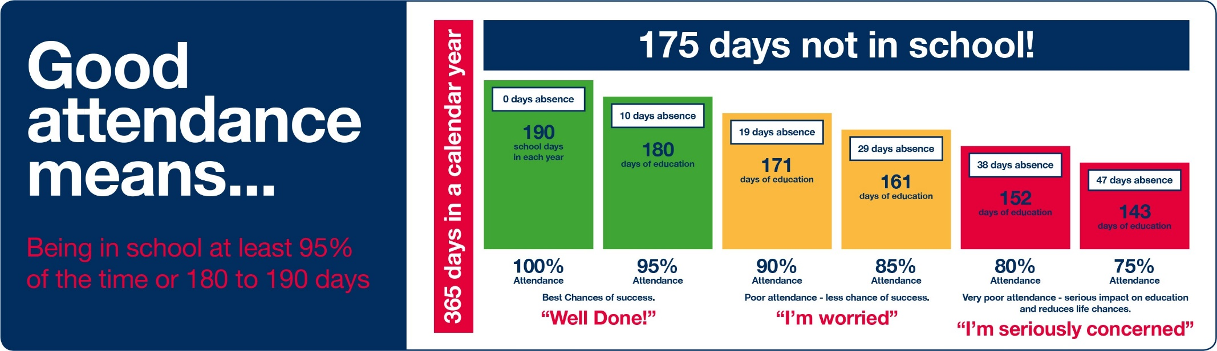
Our whole school target is 97% - 100% attendance
However we accept that some pupils may become ill or have other genuine reasons for absence. If your child is absent the School must be notified on the first day.
Please note that the School will not authorise holidays taken during term times.
Registers are marked from 8.40am to 9am and all pupils will receive a late mark if they are not in by that time.
