

Top Tips for Learning Times Tables

- Start by learning the facts in order then practise randomly.
- Write them down and chant them … but always say the whole fact.
- The 2’s, 4’s and 8’s are all doubles of each other with lots of common answers like 2 x8=16, 4x4=16 and 8x2=16
- Once you know one fact you will actually know two multiplications and two divisions!
- The nine times table can be easy to learn after the 10 times table as 10x4=40 so 9x4=36 (40-4=36)
- The 7 times table is the hardest to learn so lots of practise will be needed. (7 x8=56 is the hardest so emphasise this and make a fuss about it!)

National Curriculum suggested order for learning…
Yr 2 | Yr 2 | Yr 2 | Yr 3 | Yr 3 | Yr 3 | Yr 4 | Yr 4 | Yr 4 | Yr 4 | Yr 4
2 | 5 | 10 | 3 | 4 | 8 | 6 | 7 | 9 | 11 | 12

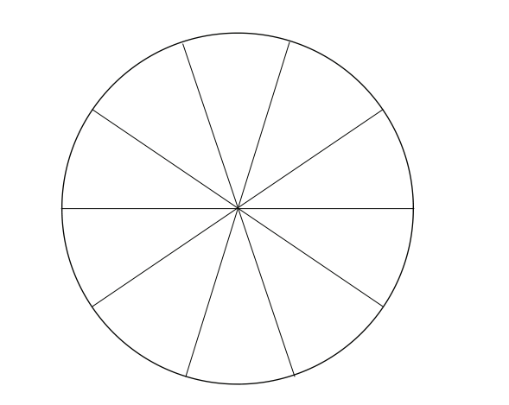
Times tables’ spinner!
We suggest letting children create their own spinner, use numbers from 3 through to 12 if they are ready, spin twice to create a fact to answer, or 1 through to 10 if they are still practising and multiply by the table they are working on currently.
Use a pen or pencil pushed through the centre as the spinner.
Matching Pairs!
- How quickly can they match the question and answer.
- The answer is …. What could the question be?
- SNAP!
- Memory game, lay all the cards out upside down, who can find the most matching pairs?

7x8 | 11x10 | 56 | 110
6x3 | 12x4 | 18 | 48
9x4 | 9x0 | 36 | 0
5x8 | 7x7 | 40 | 49
6x8 | 9x6 | 48 | 54
7x6 | 11x2 | 42 | 22
4x3 | 5x12 | 12 | 60

Helping find the answer ….

To solve multiplication problems children draw and array.
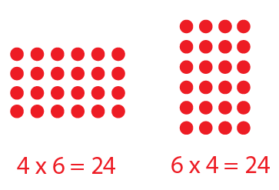

Arrays can be drawn or made using 1p coins.

When children know a fact it is good to show them which other facts they now know.

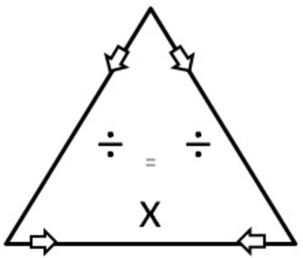
24
24 ÷ 4 = 6
24 ÷ 6 = 4
4 x 6 = 24
6 x 4 = 24

4 6
x | 1 | 2 | 3 | 4 | 5 | 6 | 7 | 8 | 9 | 10 | 11 | 12
1
2
3
4
5
6
7
8
9
10
11
12

