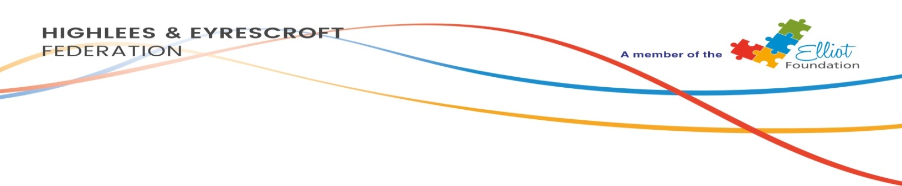
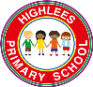 Highlees Parent Code of Conduct
- To provide our children with the best education and care, please work in partnership with school staff. We can achieve more together!
- Please respect our school ethos whenever on school premises or communicating with our school.
- Please respect everyone within our school community: refrain from using loud or offensive language; physical aggression; or threatening behaviour towards any adult or child.
- Please help keep our school safe and secure by only entering school through the school office, and always signing in.
- If you have any concerns regarding your child at all, please speak with your child’s class teacher.
- Approaching someone else’s child in order to discuss the actions of the child towards your own is not acceptable; please always speak to you child’s teacher.
- Please be cautious when using Social Media: think before you post! The online safety of our children is paramount, so please do not post images or comments about other peoples’ children. Please be vigilant on social media, for your own children and others. Report any concerns to the school office.
- Please do not smoke whilst on school grounds.
- To keep our school grounds safe for the children, please do not cycle whilst on school premises.
- Please do not bring dogs on to school grounds, except guide dogs.
- Please ensure anyone who enters school grounds on your behalf is aware of this code of conduct.
Thank you.
In order to support a peaceful and safe school environment, the parents of Highlees have contributed to our Parents Code of Conduct. We trust that all parents and carers will assist our school with the implementation of this code of conduct. We thank you for your continuing support of our school.

