Arriving Late

Our school days starts at 8.40am. We encourage pupils to be ready to start work at this time.


As soon as the classroom door opens, pupils’ learning starts with morning work and challenges.

Pupils arriving after 9am must sign in at the school office. The number of minutes late will be logged.
Being frequently late for school adds up to lost learning time.
- 5 minutes late every day adds up to 3 lost days of learning time.
- 15 minutes late every day is the same as being absent for 2 weeks a year.
- 30 minutes late every day is the same as being absent for 19 days a year.


Some strategies to improve your child’s punctuality:
- A good bedtime routine.
- Pack school bags the night before.
- Good morning routines
- Leave 5-10 minutes early to allow for traffic.

If you need support with routines at home, please speak to Mrs Edwards.

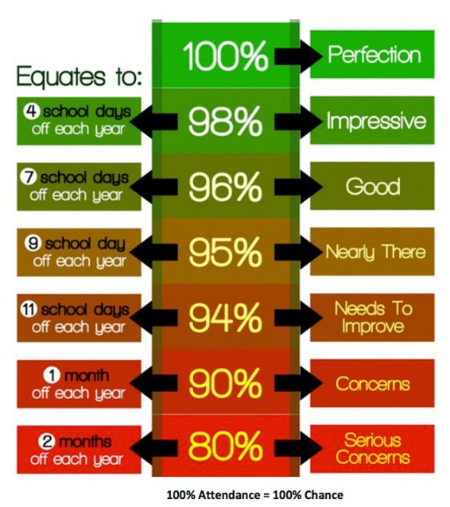

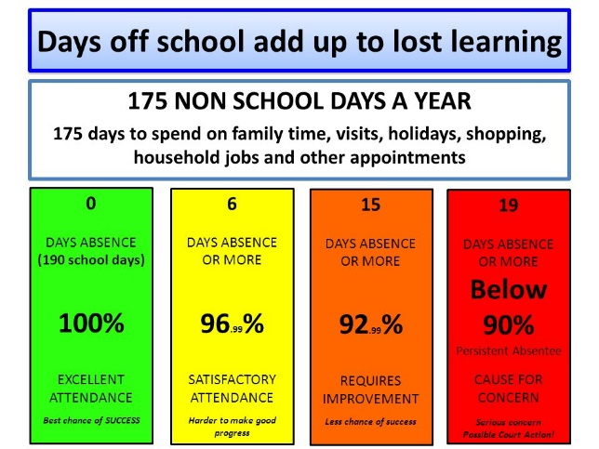
If you need any support, please speak to a member of our attendance team:
Mrs Edwards – Family Support Worker
Mrs Albert – Head of Academy
School Office – The Admin Team





Attendance
information for parents and carers



Introduction

Receiving a good full-time education will give your child the best possible start in life.

Attending school regularly and punctually is essential if children are to make the most of opportunities available to them.

Poor attendance can seriously affect a child’s attainment in school, relationships with peers and the ability to form long lasting friendships.

What you can do to help…

Make sure your child arrives at school on time. This encourages good timekeeping habits and reduces any classroom distractions.

If you child has to miss school, it is vital that you inform us on the first day of absence, preferably first thing in the morning. Simply call the office and leave a message.

If you think your child is having difficulties attending school, contact us straight away. Most problems can be dealt with very quickly.

Unauthorised absence

If your child is absent and we do not receive an explanation from you, or consider the explanation unsatisfactory, we will record your child’s absence as ‘unauthorised’.

Authorised Absence

Most absences for acceptable reasons will be authorised by the academy …
- Sickness
- Unavoidable medical/dental appointments (where possible please arrange these for after school or during the holidays)
- Days of religious observance
- Exceptional family circumstances, such as bereavement
- A visit to a prospective school

The School will not authorise absence for the following reasons …
- Shopping trips
- Day trips
- Holidays
- Birthdays
- Looking after siblings or ill relatives

Reporting an absence …
When your child is absent with prior permission, please contact the academy office:


01733 264294

or email


highleesoffice@hefed.org

Holiday Requests
Government guidance has removed the permission for head teachers to agree to term time holiday requests.

Due to the disruptive effect on a child’s education, you are strongly advised to avoid booking a family holiday during term time.

Parents and carers do not have the right or entitlement to take their child out of school for a term time holiday.




Any unauthorised leave of absence could result in a fine being issued.


Compulsory school age
Children are considered compulsory school age from 1st September, or 1st January or 1st April following their 5th birthday.

